Outline of implemented techniques

Method 1: New Color Space with PCA (Principle Component Analyses)

Main idea: Principle component analyses (PCA)

1. Mean Subtract (little trick): Instead of subtracting whole images average. Whole Image will be divided into 16\*16 blocks, each sample minus the average within the same grid.

2. Covariance Matrix: Define the sample as S, and ST × S is the covariance matrix COV of size 3×3.

3. Eigenvalue Decomposition: Perform EVD for the covariance matrix COV. Stack the eigenvectors along column to form transformation matrix Tpca

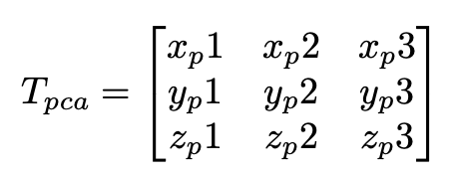

With the calculation form offered in the paper

[x1, x2, x3] = L1 normalize ([xp1, xp2, xp3]) ∗ 219/255 ScaleCb: = 224/255/(|yp1| + |yp2| + |yp3|) [y1, y2, y3] = [yp1, yp2, yp3] ∗ ScaleCb

Y offset = 16 Cb offset = −1 ∗ sum neg (y1, y2, y3) ∗ 255 + 16 Cr offset = −1 ∗ sum neg(z1, z2, z3) ∗ 255 + 16

Then we can get the transformation from RGB to this new YCbCr PCA color space.

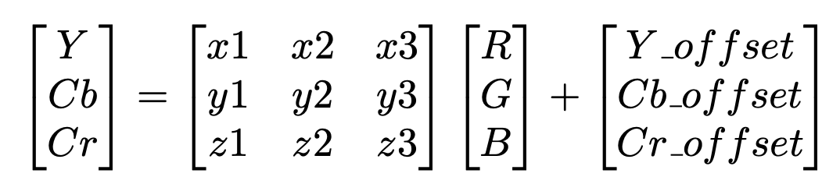

Method 2: Deep Learning with CNN

Idea source of paper(SRCNN):

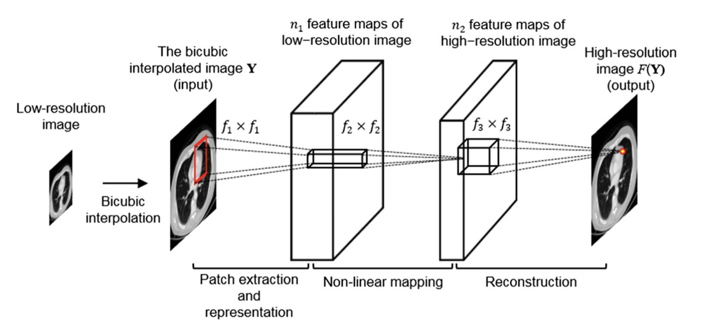

Structure from Paper(ARCNN):

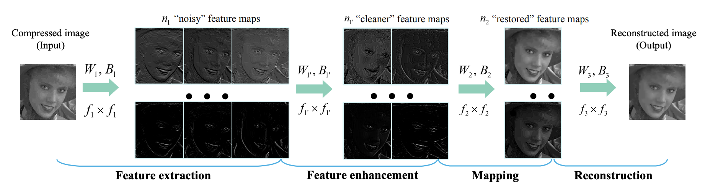

Our Improved Structure based on ARCNN

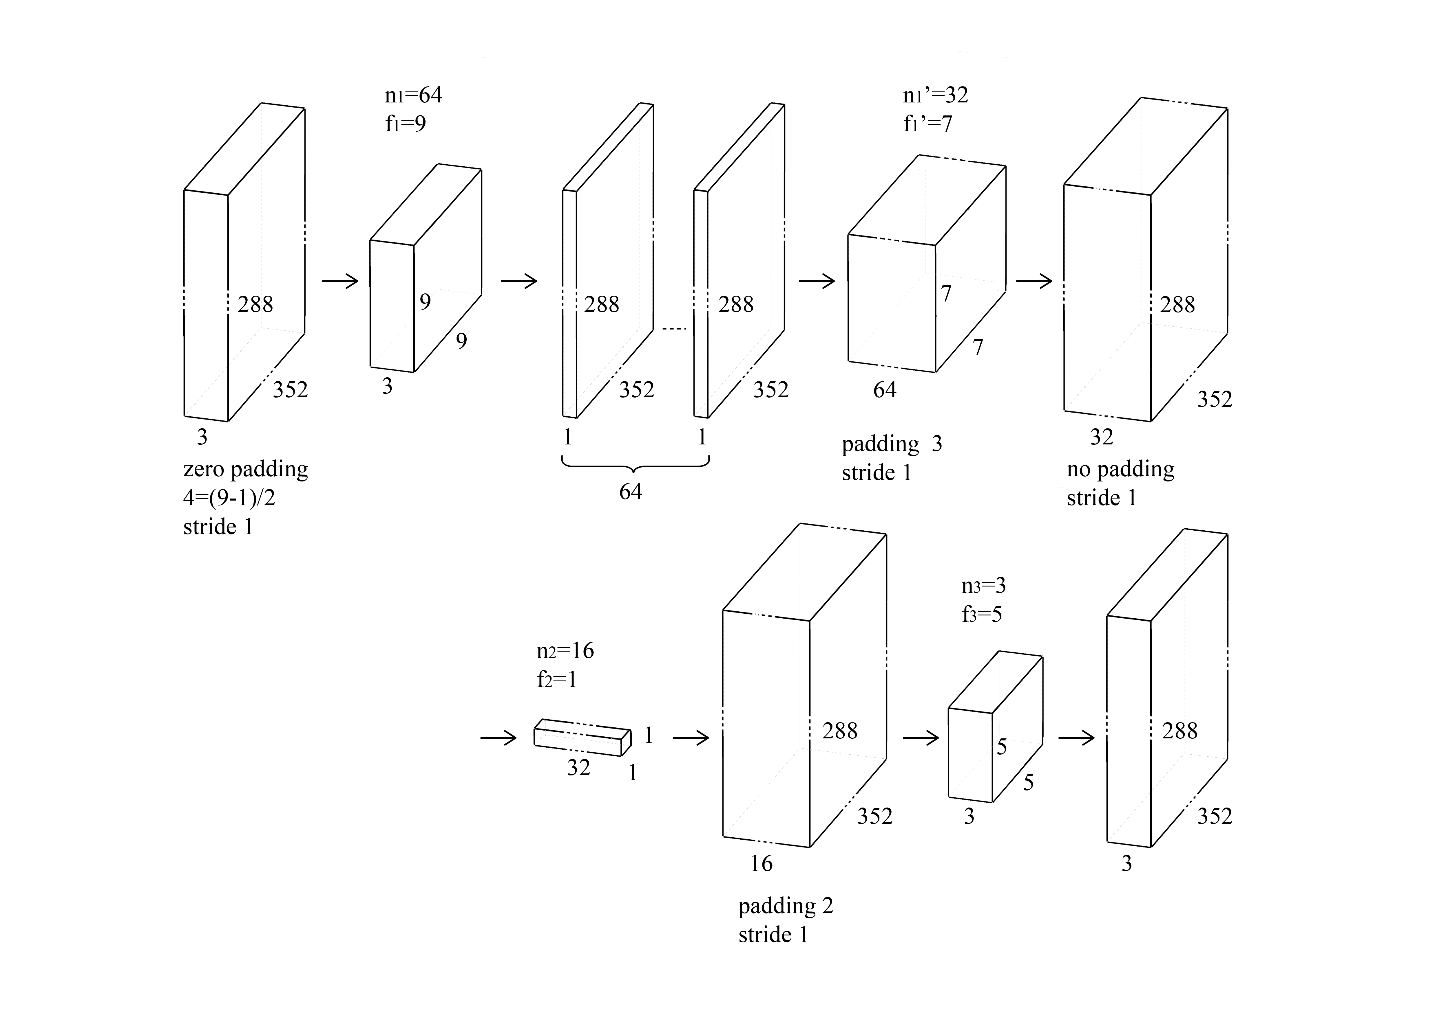

Our improvement is mostly in picture channel. In the most paper, they mostly only trained Y Channel of the picture. The reason why they only train Y Channel is because human is very sensitivity to Y Component compared with Cb and Cr component, since Cb and Cr contain the high frequency part of a picture. What we do is we train the whole RGB picture in the Network, we want to see if training directly with RGB 3 channel image can also get a good result or not.

Method 3: ARCNN+ResNet

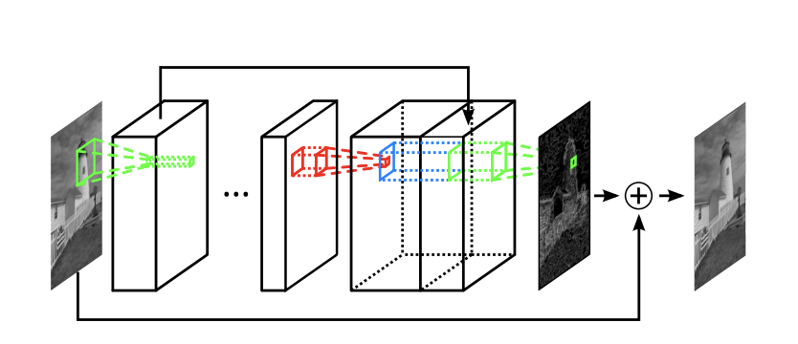

Before we just use CNN to generate a whole new picture to get a higher resolution picture. But during training and testing we find sometime if we didn’t train the network properly, we will still get a worse result. So, in this attempt we try to generate the error between our JPEG codec pictures and the ground truth pictures. We assume in this network, at least we won’t get a worse picture like above.